NATURE OF MATTER

BEHAVIOUR OBJECTIVES
At the end of this lesson, students should be able to:
- define matter.
- write the three major states of matter.
- illustrate change of state with the aid of a diagram.
- itemize 4 properties of each of the three states of matter.
- differentiate between physical and chemical changes.

Matter is anything that has mass and occupies space. It includes all known physical substances like water, soap, food, air, car. Matter is what make up our bodies, our belonging, our physical environment, and in fact our universe. Generally, matter exist in three physical states which are Solid, Liquid, Gas.
SOLID
In solid, particles are held together in an orderly fashion with little freedom of motion. There is a strong force of attraction between the particles, as a result, solids have definite volume and shape.
LIQUID
Liquid particles are loosely packed together. Liquid have definite volume but not definite shape, but takes the shape of the containing vessel. The forces holding the molecules together are not very strong and they can move over one another.
GAS
In gases, the particles are far apart from each other. The force of attraction holding the particles together is very weak. Thus, do not have definite shape nor definite volume. They fill the containing vessel and assume the shape of the vessel.
Generally, matter can change from one physical state to another when heated or cooled.
For example, In water: ICE ↔ WATER ↔ STEAM

CHANGE OF STATE WITH THE AID OF A DIAGRAM
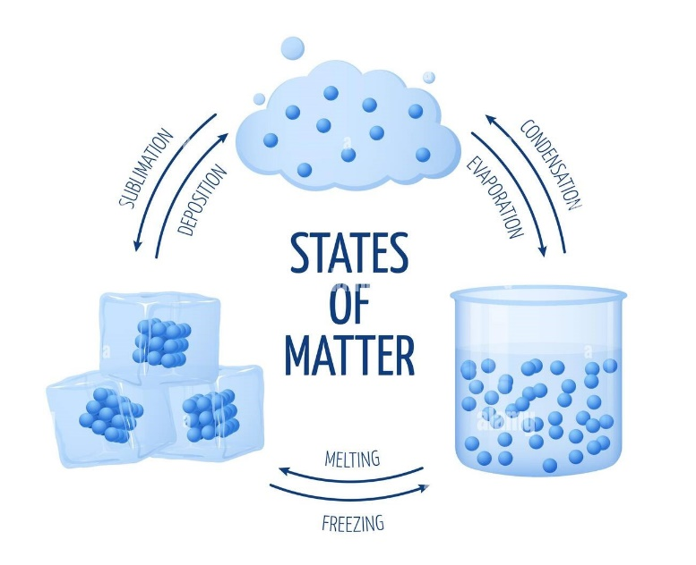
PHYSICAL AND CHEMICAL CHANGES
Physical Change: occurs when no new substance s formed and it is easily reversed. Magnetization of iron rod is a physical change because no new substance is formed and the iron rod can be recovered by the demagnetization of the iron rod. Change in state of a substance is a physical change as its components is separated by physical means and no new substance can be produced. Examples of physical change include crushing a can, shedding paper, chopping wood, melting an ice cube, breaking a bottle.

Chemical Change: occurs when a new substance is formed and is not easily reversed. It involves the absorption or emission of heat and the mass of the new substance formed differ from its initial mass. When a piece of paper is burnt, no physical method can reverse the process. Examples of chemical change include the rusting of iron, the metabolism of food in the body, cooking an egg, baking a cake, rotting bananas.

DIFFERENCES BETWEEN PHYSICAL AND CHEMICAL CHANGES
Chemical Change | Physical Change
New substances are always formed.  It is not easily reversible.  The new substance formed has different mass compared to the starting material.  A considerable amount of heat change is involved.  Has direct effect on the chemical bond of the molecule of the substance. | No new substance is formed.  It is easily reversible.  There is no change in the mass of the original substance after the change.  It does not involve great heat change.  No effect on the chemical bond of the molecule of the substance.

DRILL QUESTIONS

- Water is solid at 0ºc. Justify this statement using it properties?

- Which of the following has a definite shape?
- Water
- Hydrogen gas
- Engine oil
- Bread crumbs

- Which of the following is an example of chemical change?
- Dissolution of salt in water
- Rusting of iron
- Melting of ice
- Chopping of wood

- Which of the following gives a solid its definite shape?
- Strong intermolecular attraction
- High melting point
- High boiling point
- Weak intermolecular attraction

- Which of the following is a physical change?
- Burning kerosene
- Dissolving calcium in water
- Freezing ice-cream
- Exposing water phosphorus to air

ANSWER
- Definite shape, Definite volume
- D
- B
- A
- C

